

Experiential learning

| **Term:** I | **Branch:** AIML/AIDE |
| --- | --- |
| **Course Name:** **Computational Mathematics** | **Course Code:** 23BSMA12 |
| **Date:27/10/2023** |  |

**Note:**

1. **All the students need to submit on or before 01/11/2023.**
2. **Individual soft copies must be submitted LMS.**
3. Identifying the Replicated data and remove those data from the record using PYTHON

A survey in a particular region reveals that the following persons are owning two wheelers, mid-range cars, high end cars

**Two Wheelers:** Raju, Ravi, Anusha, **Arun**, **Arjun**, Kailash, Kishore, Raghu, **Ramu**, Abhilash, Arun, Kavitha, Karan, Kiran, Kumar, Arjun, Ramu, Aravind, Randheer, Shyam

**Mid-range Cars:** Rahul, Ravi, Anusha, Ashok, Ismail, Prabhu, Rajesh, Randheer, Shyam, Nandan, Arun, Arjun, Kailash, Kiran, Sandeep, Dinesh, Sravan, Kumar, Arjun, Raju,

**High End Cars:** Lokesh,Teja, Arundathi, Sharma, Devendra, Prasad, Kumari, Prasanna, Lalitha, Kiran, Kumar, Arjun, Ramu, Arjun, Kailash, Kiran, Randheer, Shyam

**Write a Python code to,**

1. Create a list for each case (i.e. Two wheelers, Mid-range cars, High end cars) and remove the replicated names in each list using appropriate Pythonfunction.
2. List out the people who are owning anyone of the vehicle in the region using appropriate Python function.
3. Identify the people who are owning both the two wheelers and Mid-range cars using appropriate Python function.
4. Identify the people who are owning both the Mid-range cars and High end cars using appropriate Python function.
5. List out the people who are owning all the three vehicles in the region using appropriate Python function.
6. Using laws of logics simplify the following networks shown in below figures and find the Truth values by python.

(a)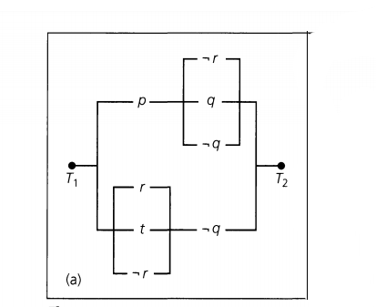

(b) 